**Project Design Phase-II**

**Data Flow Diagram & User Stories**

|  |  |
| --- | --- |
| Date | 26-06-2025 |
| Team ID | Single |
| Project Name | Freelance application mern |
| Maximum Marks | 4 Marks |

**Data Flow Diagrams:**

**Data Flow Diagram (DFD) - Freelance** **application mern**

**Level 0 (Context Diagram)**

* **External Entities**:
  + Clients (Post jobs, manage hires)
  + Freelancers (Browse jobs, submit bids)
  + Admin (Moderate content)
  + Payment Gateway (Stripe/PayPal)
* **System Boundary**: FreelanceConnect Platform

**Level 1 DFD (Core Processes)**

1. **User Management**

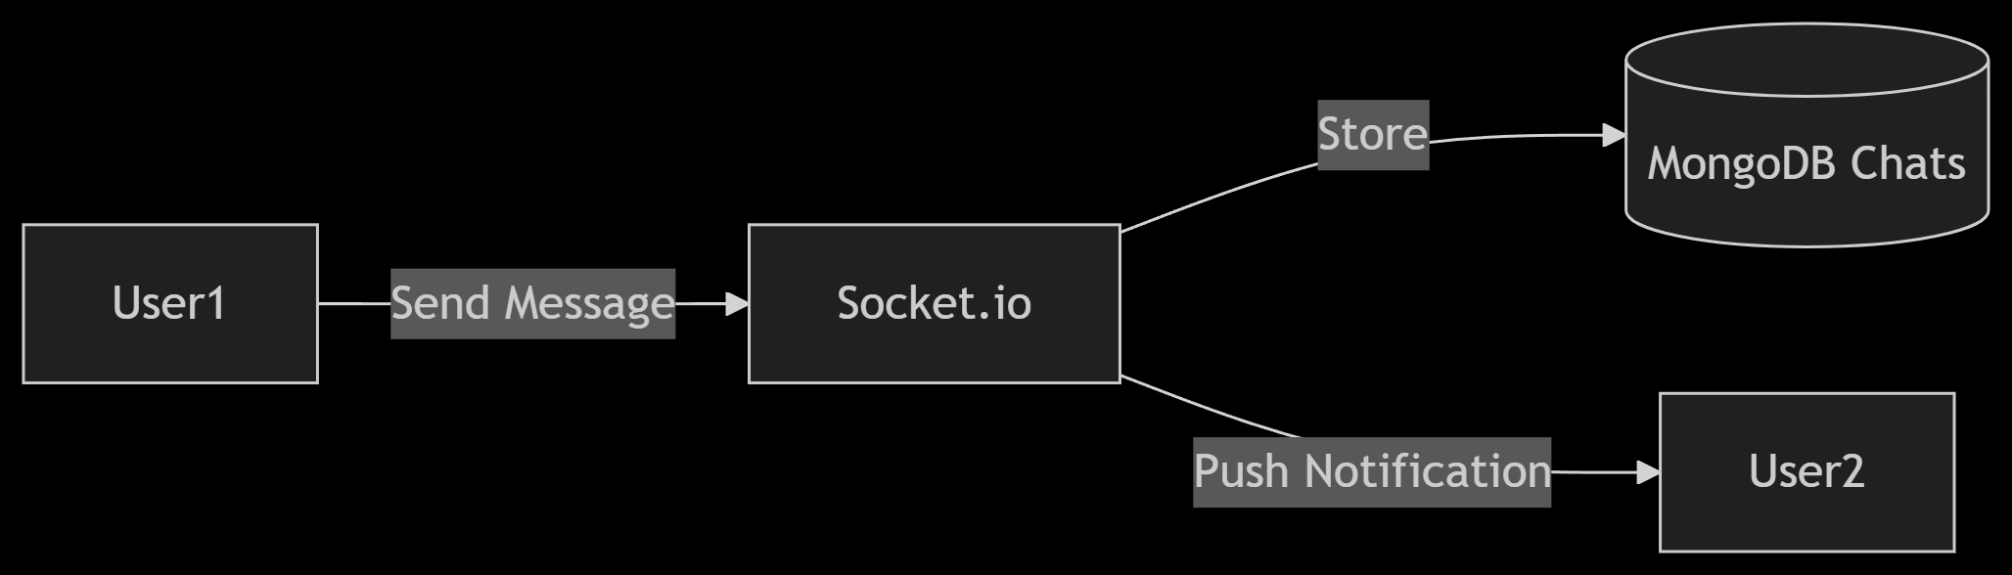

* **Data Stores**: Users Collection (role, email, hashed password)
* **Flows**: Registration form → Express.js validation → MongoDB

**2. Job Lifecycle**

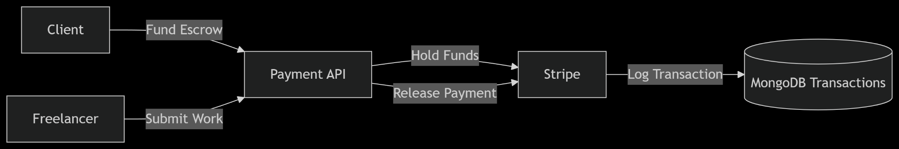

* **Data Stores**: Jobs Collection (title, budget, bids[])
* **Flows**: Job creation → Bid submission → Hiring status

1. **Payment Flow**

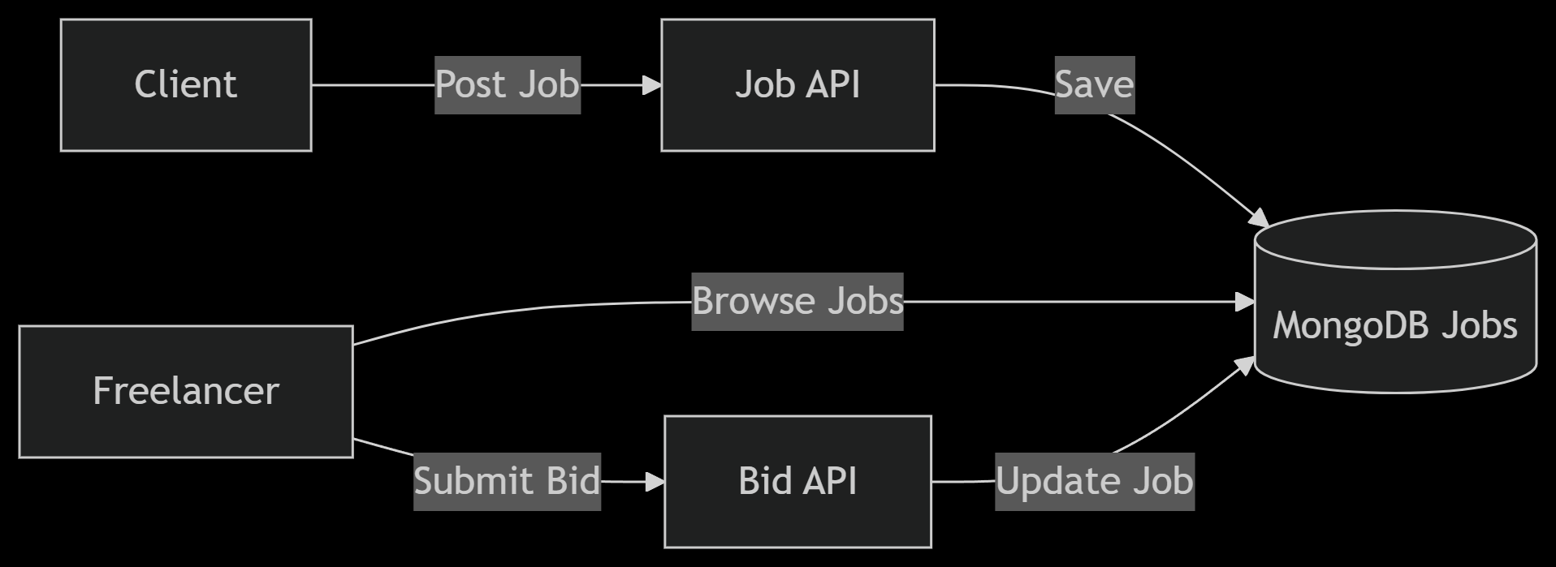

* **Data Stores**: Transactions Collection (amount, status, timestamps)

1. **Real-Time Chat**

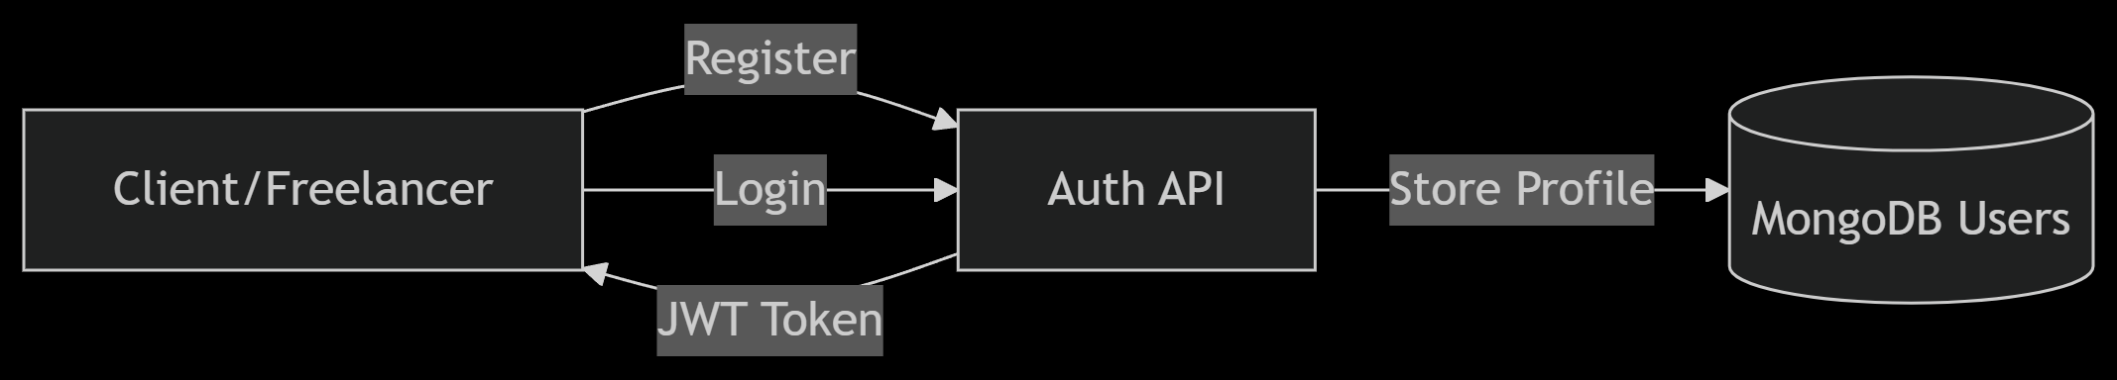

* **Data Stores**: Chats Collection (sender, recipient, message)

**Key Data Stores (MongoDB Collections)**

| **Collection** | **Schema Highlights** | **Relationships** |
| --- | --- | --- |
| users | role, email (unique), skills[], rating | References jobs/bids |
| jobs | title, budget, clientID, bids[] | Embedded bids[] |
| transactions | amount, status, jobID, timestamps | Tied to jobs/users |
| chats | participants[], messages[] (with read status) | Indexed by user pairs |

**Security & Validation**

* **Data In Transit**: HTTPS for all API calls, Socket.io over WSS
* **Data at Rest**: MongoDB encryption, sensitive fields (e.g., passwords) hashed
* **Input Validation**:
  + Express.js middleware for job postings/bids
  + React Formik + Yup for frontend forms

**Tools to Generate DFD**

1. **Lucidchart** / **Draw.io** (For professional diagrams)
2. **Mermaid.js** (For code-based flowcharts, as shown above)
3. **Visual Paradigm** (For multi-level DFDs)